Tokenize example:

Loading the data to a relation A

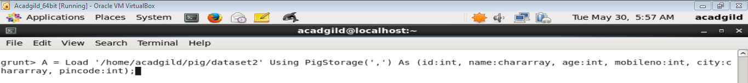

Viewing the relation A by Dump Command

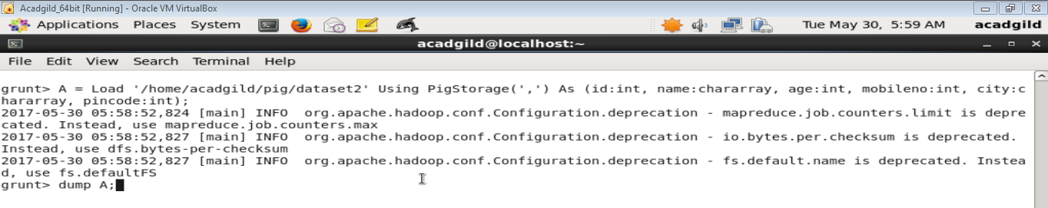

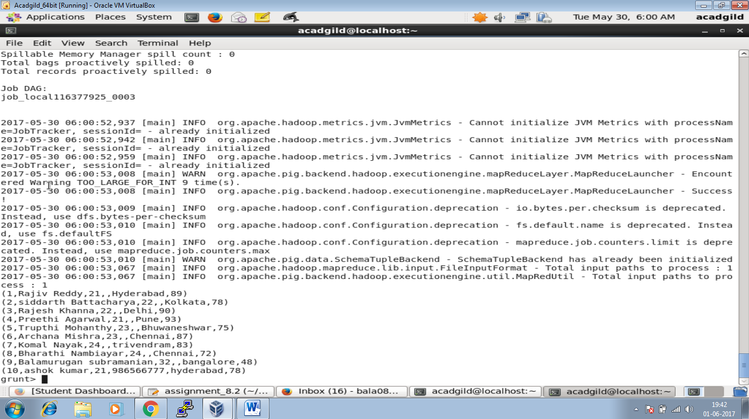

Using tokenize spilt a group of word.



Viewing the tokenized data using dump



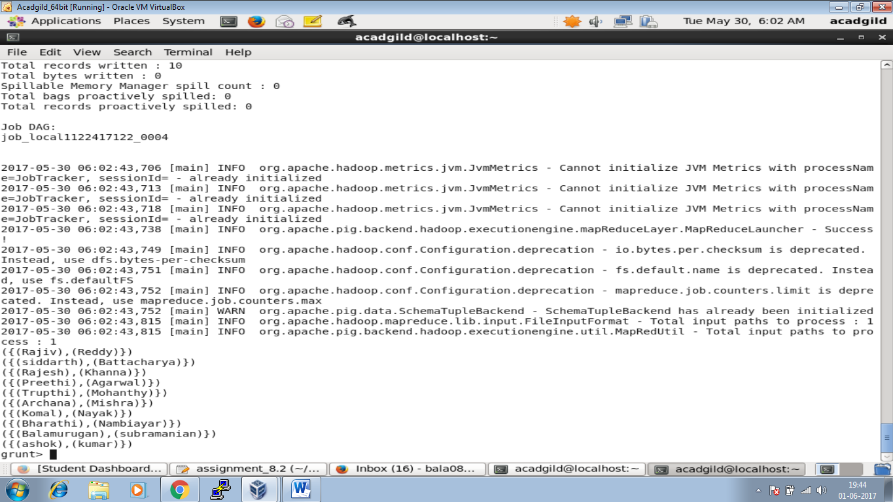

Code for Tokenizing the data

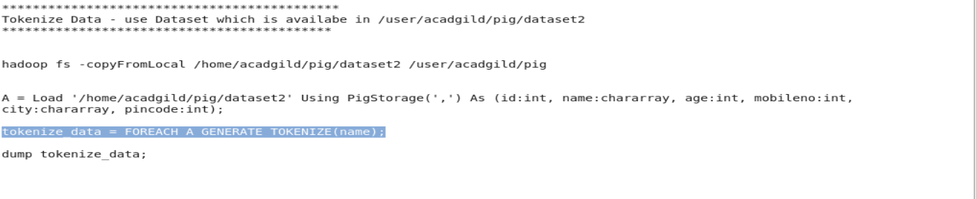

Data Set Used:

